**Doug Chang 04612354**

**Problem 1: Expression Regulation**

Voigt and colleagues have engineered a system to control gene expression in *E. coli* through light exposure. They introduced enzymes, Ho1 and PcyA, to convert heme (already present in the bacteria) to a photosensitive receptor, Pcb. The Pcb receptor activates promoter PompC only if light is not present. They then linked the promoter to expression of the enzyme LacZ, which catalyzes the conversion of a small molecule present in the media (S-gal) into a dark compound for detection.

Here, we’ve altered the system to include additional forms of regulation, namely the addition of the lacI repressor to give another degree of control. (The table below summarizes the key parts of the engineered system):

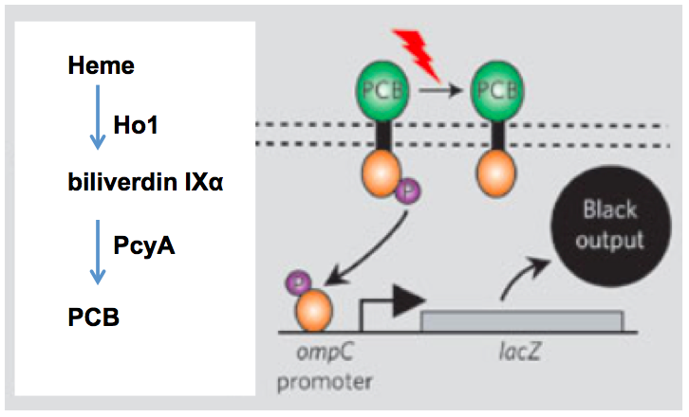

|  |  |
| --- | --- |
|  | **Function** |
| **Genes** | |
| *lacZ* | Codes for an enzyme that converts S-gal to a black pigment |
| *pcyA* | Codes for expression of an enzyme that converts biliverdin Ixα to the Pcb receptor |
| *lacI* | Codes for Lac repressor which binds to the lac operator sequence (*lacO*), preventing transcription from any upstream promoter; IPTG binding causes lac repressor to dissociate from the lac operator |
| *ho1* | Codes for expression of an enzyme that converts heme to biliverdin IXα |
| **Promoters, terminator, and RBS** | |
| Pcmv | Constitutive promoter; always “on,” unless activity blocked by a repressor protein bound downstream |
| PompC | Promoter that is only “on” if protein Pcb has not been activated by light |
| T: Terminator | Generic terminator that terminates transcription for any gene or operon |
| RBS: Ribosome binding site | Required to initiate translation |
| **Operators** | |
| *lacO*: Lac operator | Bound by lac repressor |
| **Small molecules** | |
| IPTG: Isopropyl β-D-1- thiogalactopyranoside | Binds to Lac repressor, causing it to dissociate from the lac operator; diffuses freely into the cell, but is not degraded |

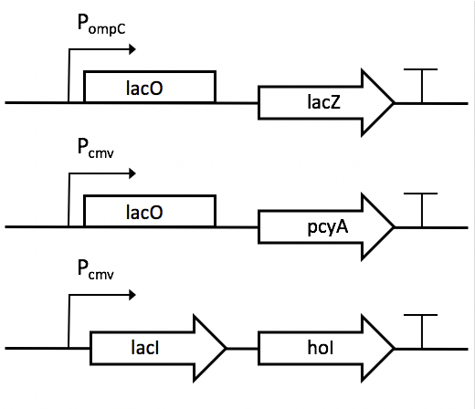

1. Add RBSes where needed in the diagram above using asterisks.   
     
   RBS upstream of start codon in mRNA which means it is upstream of the genes but after the promotor arrow.

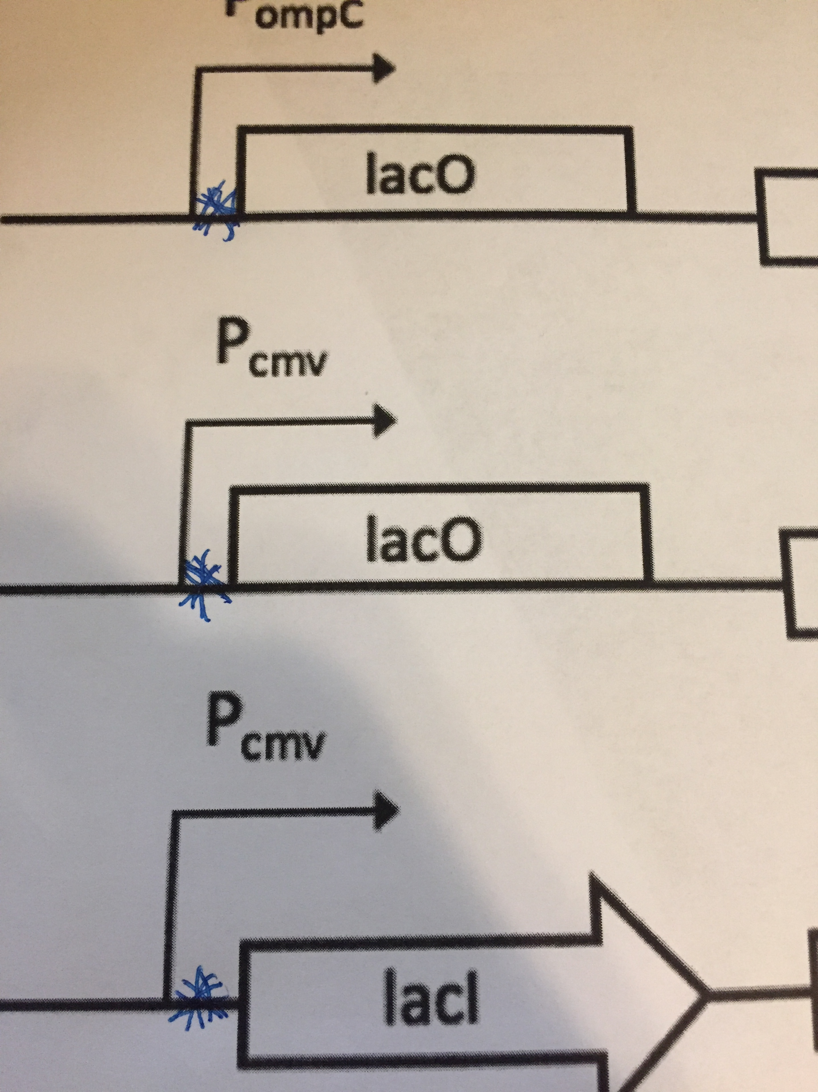

**(B)** Fill in the following table with the outputs given the indicated inputs:  
Use (+) to indicate an output is present and (-) to indicate the output is absent.

|  |  |  |  |  |
| --- | --- | --- | --- | --- |
| **IPTG** | **light** | **pcyA** | **ho1** | **lacZ** |
| **-** | **-** | **-** | **+** | **-** |
| **+** | **-** | **+** | **+** | **+** |
| **-** | **+** | **-** | **+** | **-** |
| **+** | **+** | **+** | **+** | **-** |

lacI gene used because it isn’t leaky. Produces higher levels of lac repressor. lacI always on creating lac repressor. Promotor Pcmv is always on.

start: no IPTG, no light, ho1 always on: heme->Ixa, lacZ off

add light, no IPTG, no effect because lacO keeps lacZ off.

Turn light off

Add IPTG; leave light off Removes the lac repressor allowign lacO to turn on. Ixa->Pcb, Pcb+nolight->PompC->lacZ->S-ga->Black

Turn light on:IPTG already present so no lac repressors, light stops PompC and stops lacZ

**Problem 2: Protein Expression and Folding**

We are seeking to make a 35,000 MW protein for a new Hepatitis B vaccine using the cell-free method, which is essentially *in vitro* protein synthesis. Our desired protein seems to have folding problems, and, at the moment, most of the protein accumulates as aggregates. We are going to attempt to improve folding by lowering the reaction temperature. After an analysis of *in vitro* protein folding, we estimate that the folding rate constant is 1.5 hr-1 and the second order rate constant for aggregation is 2.0 hr-1 μM-1 based on the estimated concentration of the nascent (unfolded) protein.

* + 1. In our cell-free system, the rate of translation is 4 amino acids per ribosome per second, and we have a steady-state mRNA concentration of 0.003 μM and 5 ribosomes per message. What will be the rate of production of *properly folded* protein? (Assume average amino acid MW of 110 g/mol).   
         
       Folding rate $\frac{dP_{fold}}{dt}=k_{p}N$  
         
       Aggregation rate $\frac{dA}{dt}=k_{agg}N^{n}$  
         
       Proper Folding rate = Folding Rate - Aggregation Rate  
       = $k_{p}N-k_{agg}N^{2}atsteadystate$  
         
       FInd N.  
         
       Both process competing simultaenously for mRNA as described in lecture. Solve w/quadratic equation $k_{p}N-k_{agg}N^{2}=.003μM$  
         
        ; N = .74uM and .002uM.   
       Test both roots for validity. .002 uM correct.   
       Proper Folding rate(mRNA) = $\frac{1.5}{hr}.002(μM)-\frac{2}{hrμM}(.002μM)^{2}=\frac{.003μM}{hr}-\frac{8*{10}^{-6}μM}{hr}approx.003mRNAμM/hr$  
         
       We need to use the 35000 MW and the ribosomes to get the number of proteins per hour from mRNA. $\frac{35000MW}{110g/mol}=318AA\frac{318}{5ribosomes/AA}=63mRNA/protein$ $\frac{.003μMmRNA}{63mRNA/protein}=4.7x{10}^{-5}μMprotein/hr$

1. Under these conditions, what percent of the product will be properly folded?

$\frac{rate_{properfold}}{rate_{total}}=\frac{k_{fold}N-k_{aggregate}N^{2}}{k_{fold}N+k_{aggregate}N^{2}}$ = $\frac{1.5(.002)-2(.002)^{2}}{1.5(.002)+2(.002)^{2}}$ 
=99.5%

1. Why might lowering the reaction temperature result in improved protein folding?   
   Lowering the temperature reduces the mean diffusion path length and would reduce the probability of aggregation. Increasing the temperature increases the mean diffusion length allowing reactants to move further away from the gene of interest/ribosomes/AA/molecular chaperones which are resposible for synthesis and folding.